1. Design DFA using simulator to accept the string start with a or b over the set {a,b}

INPUT:

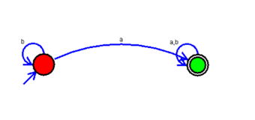

OUTPUT:

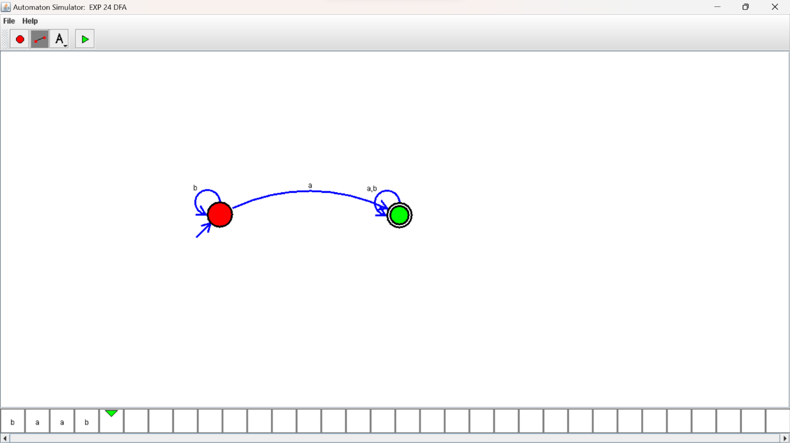

RESULTS:

DFA using simulator to accept the string start with a or b over the set {a,b}